ESTIMATION OF BUSINESS EXPENSES

# INTRODUCTION:

Estimation of business expenses is the process of forecasting and calculating the costs associated with running a business. It involves predicting the various expenditures a company is likely to incur in order to plan for budgeting, financial management, and decision-making. This can encompass a wide range of costs, including fixed expenses like rent and salaries, variable expenses like materials and utilities, as well as discretionary expenses such as marketing and travel. Accurate expense estimation is crucial for effective financial planning and ensuring the sustain ability and profitability of a business.

# SIGNIFICATION ABOUT ESTIMATION OF BUSINESS EXPENSES:

Fixed Costs:

These are regular, predictable expenses that don't change with your level of production or sales. Examples include rent, insurance, and salaries.

Variable Costs:

These expenses fluctuate with your business activities. Common variable costs include materials, labor, and utilities.

One-time Expenses:

Consider any upcoming expenses that don't recur, such as purchasing new equipment or renovating your workspace.

Marketing and Advertising:

Estimate costs related to marketing campaigns, advertising, and promotions.

Administrative Expenses:

This includes office supplies, software subscriptions, and other administrative costs.

Taxes:

Plan for income taxes and any other relevant business taxes.

Contingency:

It's wise to set aside a portion of your budget for unexpected or emergency expenses.

Depreciation:

If you have assets like equipment, consider their depreciation over time.

Loan or Interest Payments:

Include monthly loan payments or interest expenses if applicable.

Travel and Entertainment:

If your business involves these expenses, estimate and allocate a budget.

Professional Services:

Account for legal, accounting, or consulting fees.

Insurance:

Don't forget to factor in insurance premiums for liability, health, or other coverage.

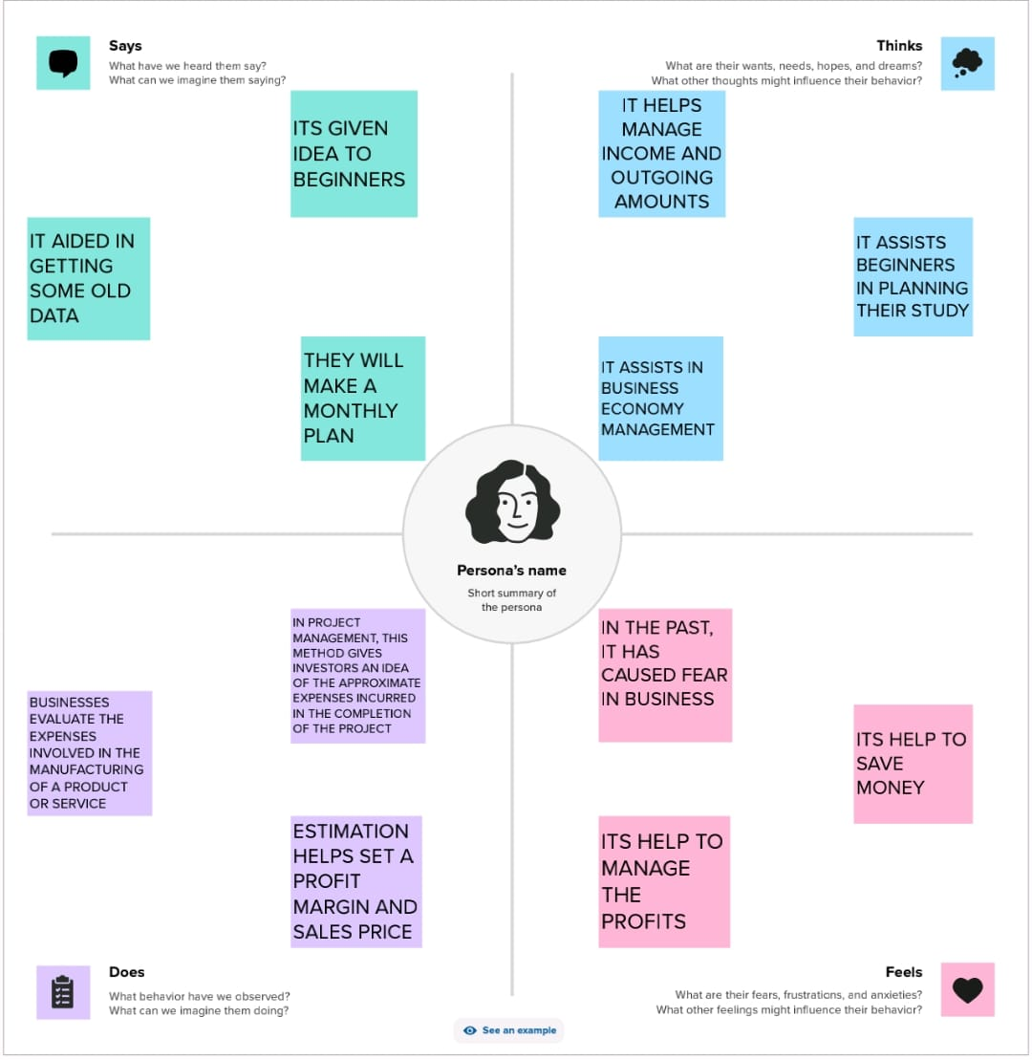

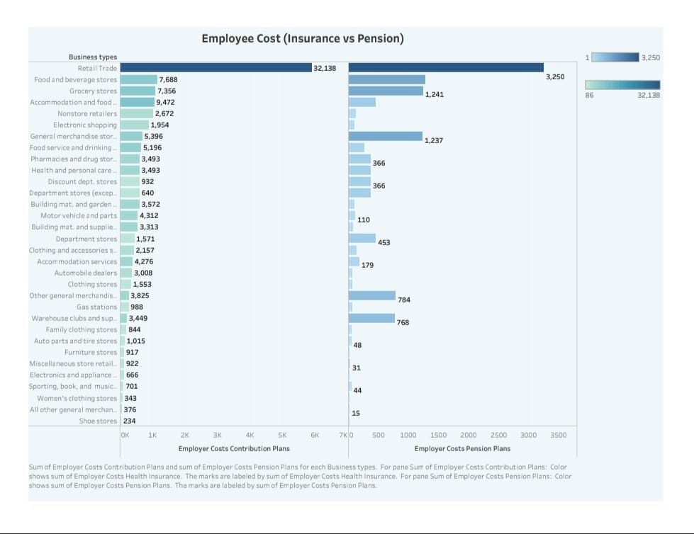

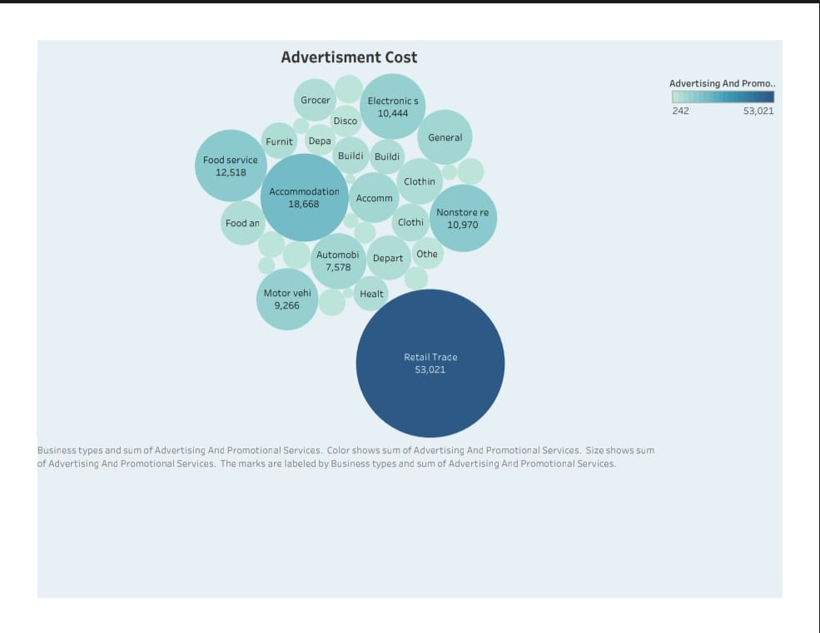

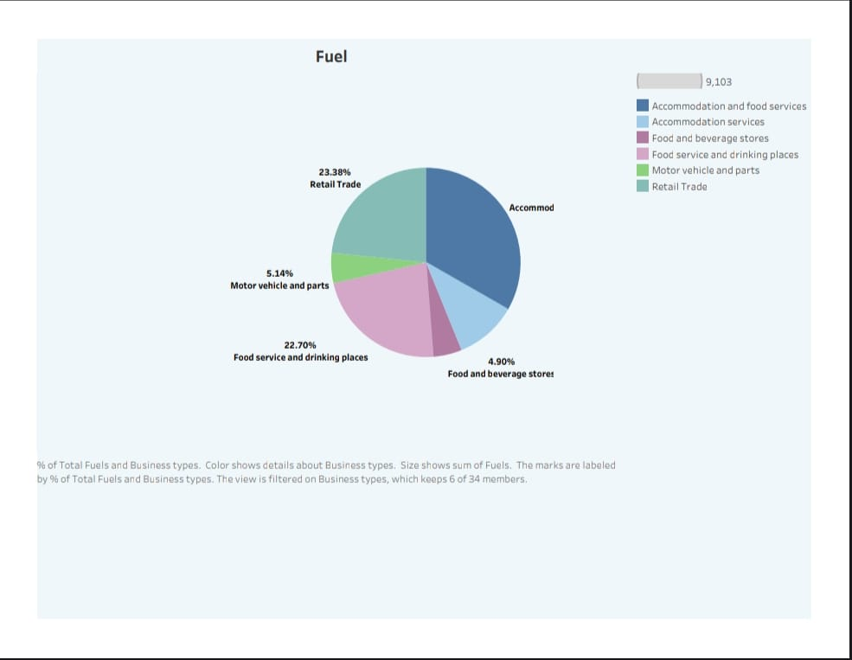

# APPLICATION OF ESTIMATION OF BUSINESS EXPSNESE:

Budgeting:

Estimating expenses is essential for creating an accurate budget, allowing a business to plan and allocate resources effectively.

Financial Planning: It aids in long-term financial planning, helping a business set realistic financial goals and objectives.

Pricing Strategy: Estimating costs informs pricing strategies, ensuring products or services are priced to cover expenses and generate a profit.

Cost Control: Estimations help in identifying cost-saving opportunities and areas where expenses can be reduced or optimized.

Funding Requests: When seeking external funding, such as loans or investments, accurate expense estimates are vital to demonstrate financial need and sustainability.

Decision-Making: Estimating expenses assists in making informed decisions regarding investments, expansions, and resource allocation.

Tax Planning: It is useful for tax planning, ensuring that the business is prepared for tax liabilities and deductions.

Performance Evaluation: Comparing estimated expenses to actual expenses helps assess the financial performance of the business and make necessary adjustments.

Risk Management: By anticipating potential expenses, a business can better prepare for unexpected financial challenges and risks.

Benchmarking: It allows a business to compare its expense estimates with industry benchmarks to gauge competitiveness and efficiency.